Assignment Name
[Name]
[Index

Table of Contents
1. Introduction 2
2. Understanding MVC Architecture 2
3. Implementing the Singleton Pattern 3
4. Technical Challenges and Solutions 3
5. Learning Outcomes and Reflection 3
6. Conclusion 4
7. Appendix 5
7.1 Appendix A – Git Log 5
7.2 Appendix B – NHS Referral System 6

Introduction
This report is the reflection on the NHS Referral Management System, which is a desktop application created in Java, the Model-View- Controller (MVC) architectural pattern, and the Singleton design pattern. The project needed to develop an inclusive healthcare management system that contains 7 modules, which are interconnected and handle patient, clinician and facility information, appointments, prescription, referral, and staff information.

Understanding MVC Architecture
The MVC pattern was an important one in structuring the application. All the business logic and data structures were encapsulated in the Model layer which consisted of the following seven classes: Patient, Clinician, Facility, Appointment, Prescription, Referral, and Staff. Each model class had the right getters, setters and validation logic and data integrity across the application was guaranteed. The View layer was composed of custom JPanel components of each module that are user-friendly and have search features, data tables and action buttons. The Controller layer was the mediator which directly received the interactions of the users and processed the business logic and rendered the views respectively. This separation of concerns allowed the codebase to be maintained and scaled so that each layer can be modified independently without causing any impacts to others.
Data transfer between layers was one of the major challenges. First, the views and the models were tightly coupled, leading to dependencies that made it more complex to test and maintain. The application became more modular with an adequate MVC separation, in which the role of controllers was only communication between models and views. This made it easier to debug, and later to make enhancements since only in very rare cases was it necessary to make changes in more than one layer.

Implementing the Singleton Pattern
The Singleton design was realized with the help of the Referral Manager class and only one such class did all of the referral processing during the application lifetime. This design decision was essential to achieve the consistency of referral queuing, audit recording, and emailing. The singleton instance would orchestrate referral processes, issue formatted email notifications, as well as audit trails of all referral processes.
The implementation involved thread safety and institute management. Concurrent access to the singleton instance would not create any other instances and destroy the shared data because of the synchronous and consistent approach. The main benefit of the singleton pattern was that there is centralized control regarding referral processing that avoids the possibility of inconsistency that may be created by the numerous instances of referral management.

Technical Challenges and Solutions
CSV processing was found to be very problematic, especially on data persistence and work with null values. AV utility classes of CSVReader and CSVWriter were created to address the edge cases, such as comma-separated values in quotes, and missing data fields. The introduction of the generic add and edit dialogs made the development of all the seven modules smooth which encouraged reusability of the code.
The design of the user interface had to be based on a balance between the functionality and usability. The original implementation had an issue with color rendering in which the table headers and the buttons had white text and a white background. This was fixed by making the explicitly defined properties of the Swing components to contain their opacities and content areas, proving to be very important to comprehend the rendering properties that are unique to the framework.

Learning Outcomes and Reflection
This project has achieved a lot in terms of my learnings in software architecture principles. Practical implementation with MVC pattern helped to identify the effects of the decisions made in architecture on maintainability, testability, and scalability. The implementation of the Singleton pattern has shown the usefulness of design patterns in addressing particular issues of software engineering.
The Git version control was invaluable, as it allowed systematic monitoring of the progress in the development process with the help of 25+ commits. This convention made it easier to review and rollback codes and even develop in a collaborative manner.

Conclusion
NHS Referral Management System supported the significance of the correct architectural planning and design patterns usage. The MVC architecture was good in its structure and separation of concerns, whereas the Singleton pattern was used to maintain referral uniformity. These are the experiences that will be applied in further software development projects with the understanding that architectural decisions are very crucial in developing maintainable and scalable applications.

Appendix

Appendix A – Git Log
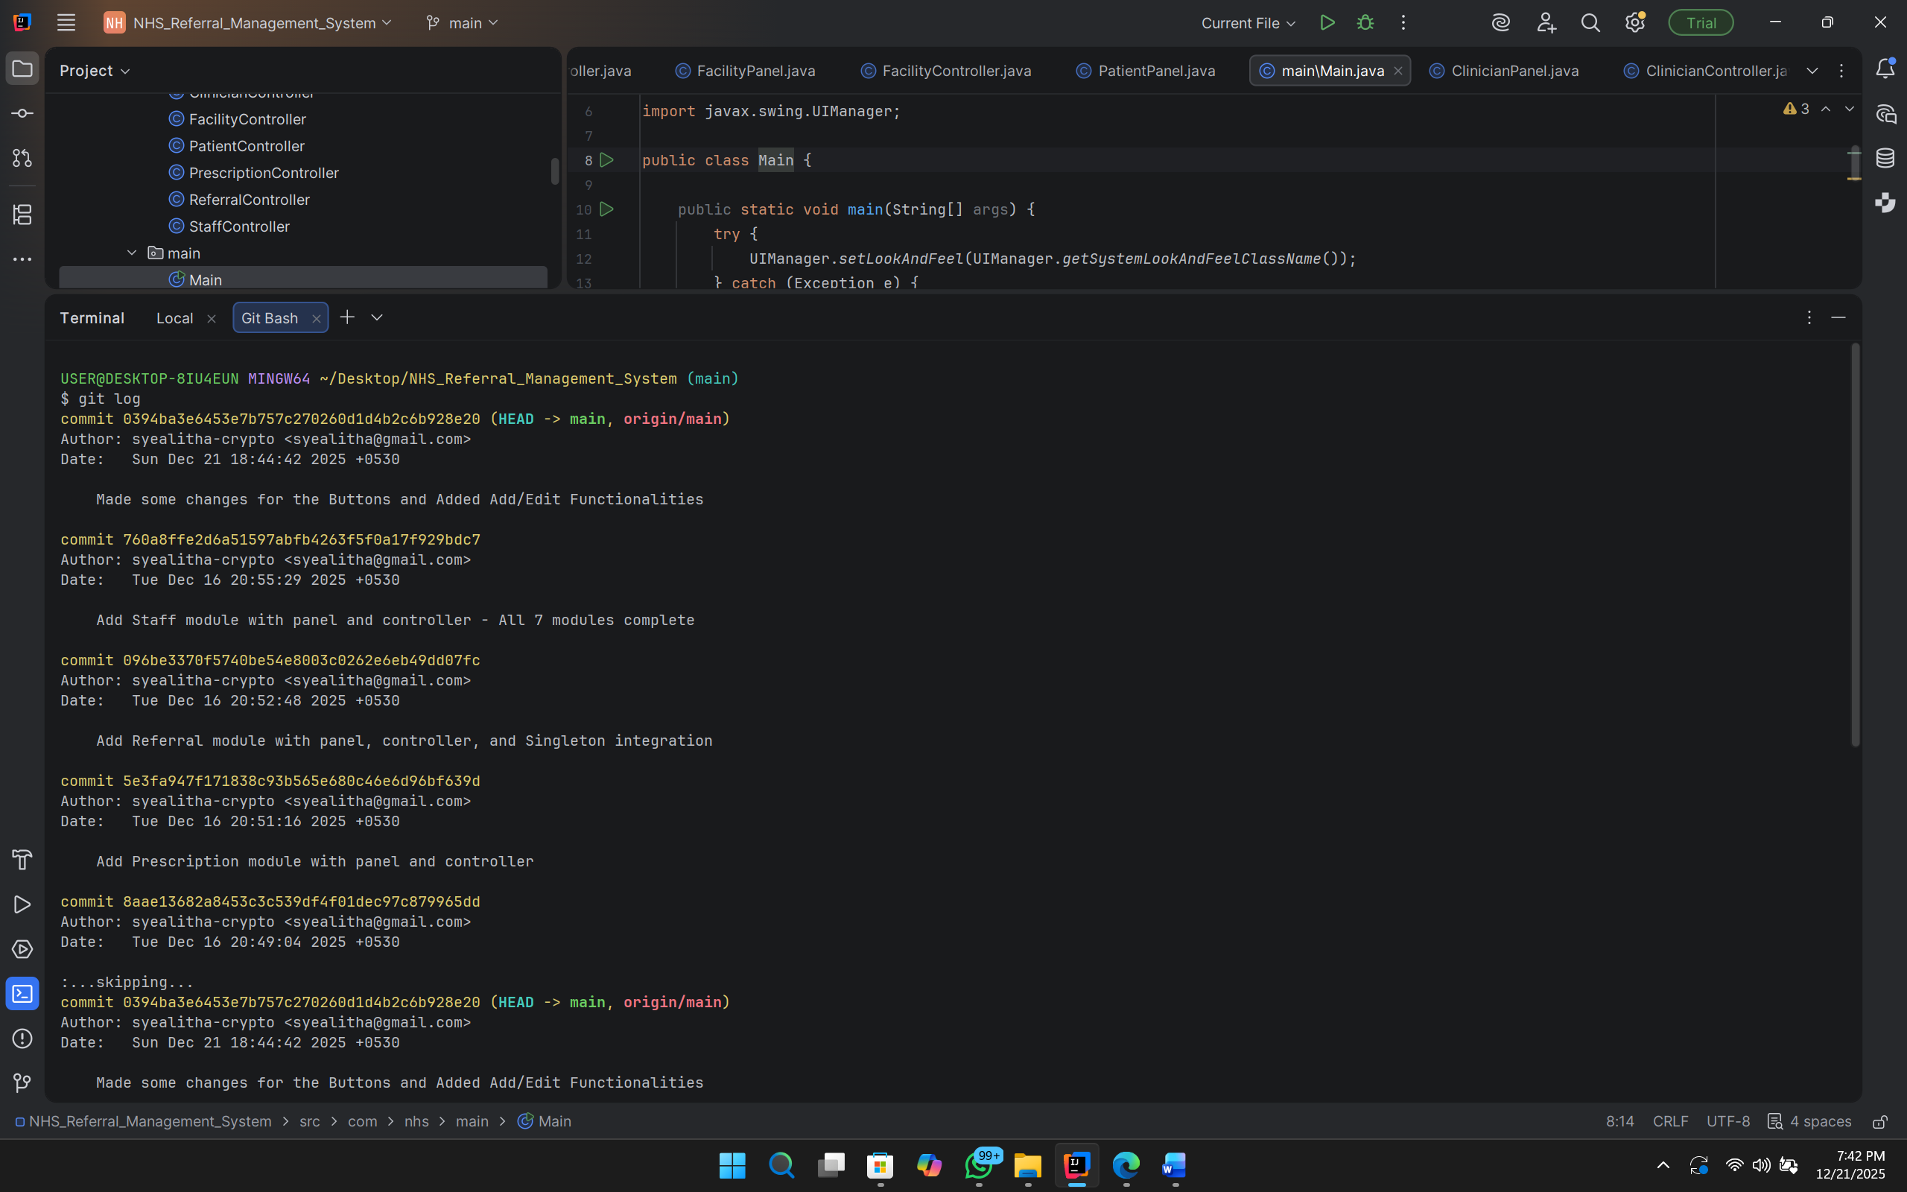
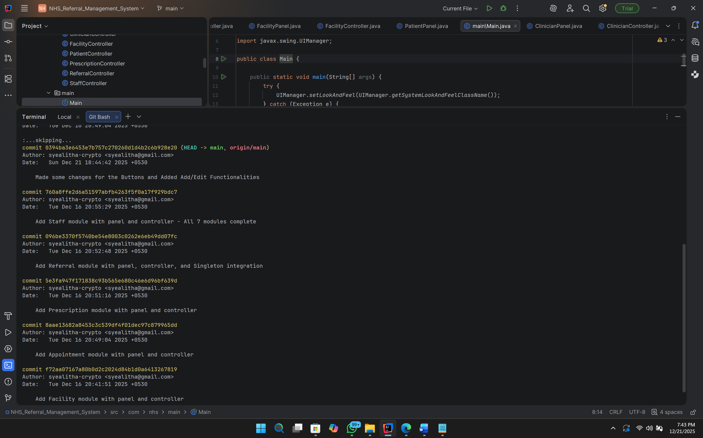

Appendix B – NHS Referral System
